Location of the Art Class:
One Church 855 Chapel Ave. South Windsor CT. 06074.
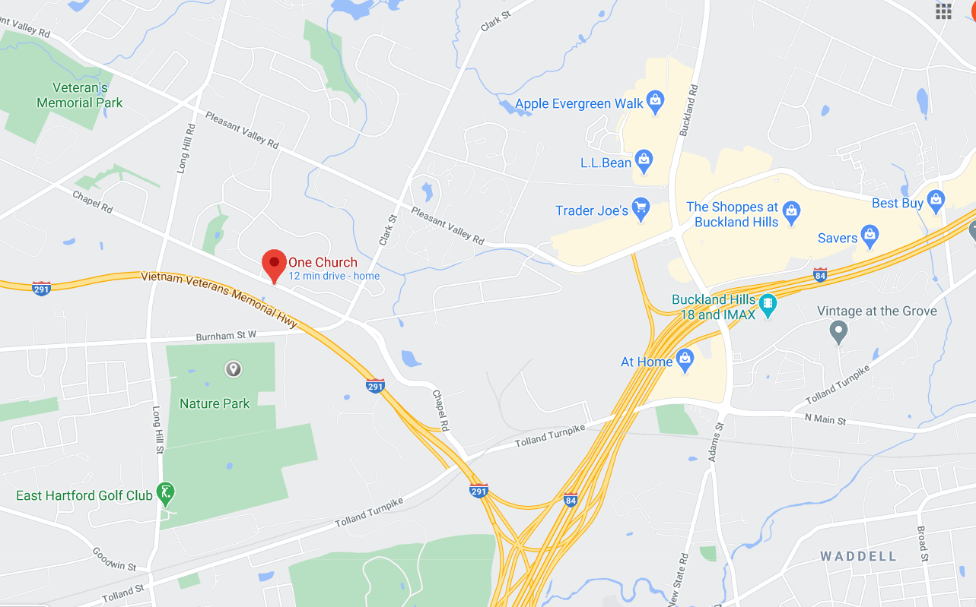
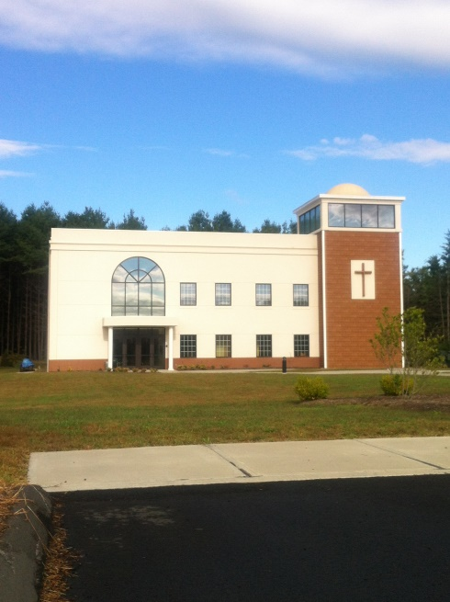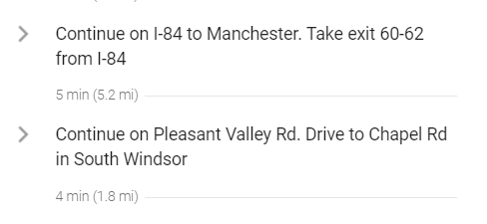

The shopping center where Trader Joes is has several fast food shops ( Taco Bell, Jersey Mikes, Five Guys).

